## Curtin University – Department of Computing

## **Assignment Cover Sheet / Declaration of Originality**

## Complete this form if/as directed by your unit coordinator, lecturer or the assignment specification.

| Last name: | Bevacqua | Student ID: | 20162896 | |
| --- | --- | --- | --- | --- |
| Other name(s): | Austin | | | |
| Unit name: | Capstone Computing Project 1 | Unit ID: | ISAD3000 | |
| Lecturer / unit coordinator: | Senjian An | Tutor: |  | |
| Date of submission: | 27/05/2022 | Which assignment? | Milestone 5 | (Leave blank if the unit has only one assignment.) |

## I declare that:

## · The above information is complete and accurate.

## · The work I am submitting is *entirely my own*, except where clearly indicated otherwise and correctly referenced.

## · I have taken (and will continue to take) all reasonable steps to ensure my work is *not accessible* to any other students who may gain unfair advantage from it.

## · I have *not previously submitted* this work for any other unit, whether at Curtin University or elsewhere, or for prior attempts at this unit, except where clearly indicated otherwise.

## I understand that:

## · Plagiarism and collusion are dishonest, and unfair to all other students.

## · Detection of plagiarism and collusion may be done manually or by using tools (such as Turnitin).

## · If I plagiarise or collude, I risk failing the unit with a grade of ANN (“Result Annulled due to Academic Misconduct”), which will remain permanently on my academic record. I also risk termination from my course and other penalties.

## · Even with correct referencing, my submission will only be marked according to what I have done myself, specifically for this assessment. I cannot re-use the work of others, or my own previously submitted work, in order to fulfil the assessment requirements.

## · It is my responsibility to ensure that my submission is complete, correct and not corrupted.

| Signature: | AUSTIN BEVACQUA | Date ofsignature: | 27/05/2022 |
| --- | --- | --- | --- |

## 

*ISAD3000 Capstone Computing Project Milestone 4 Individual Report*

***Austin Bevacqua***

***Group E8: Amristar Industry Project [Virtual Jukebox]***

Group Members:

Austin Bevacqua, Bradley van der Zwan, Dillon Vincent,   
Ryan Webster, Tanaka Chitete

# Contents

**Assignment Cover Sheet / Declaration of Originality** **1**

**Progress Tracking** **5**

**Summary** **9**

## 

## Progress Tracking

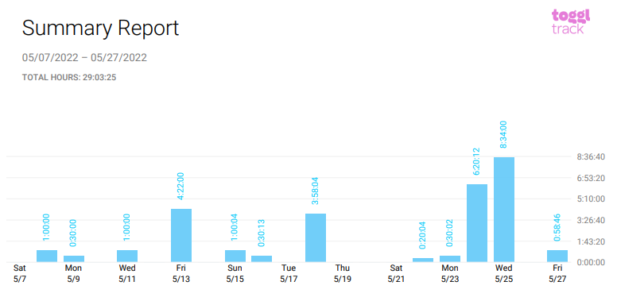

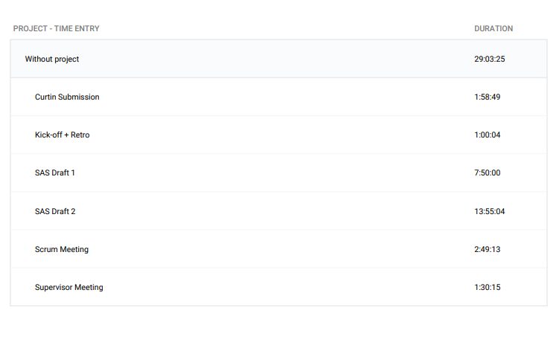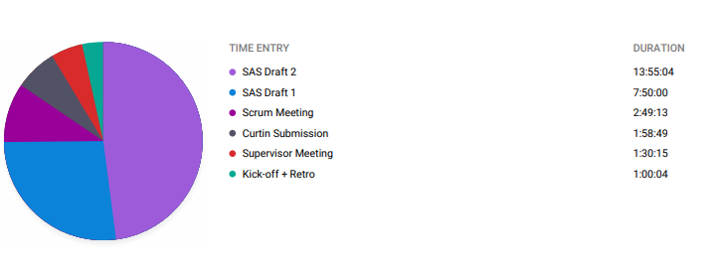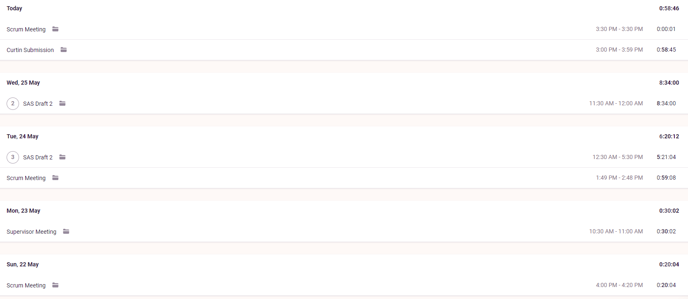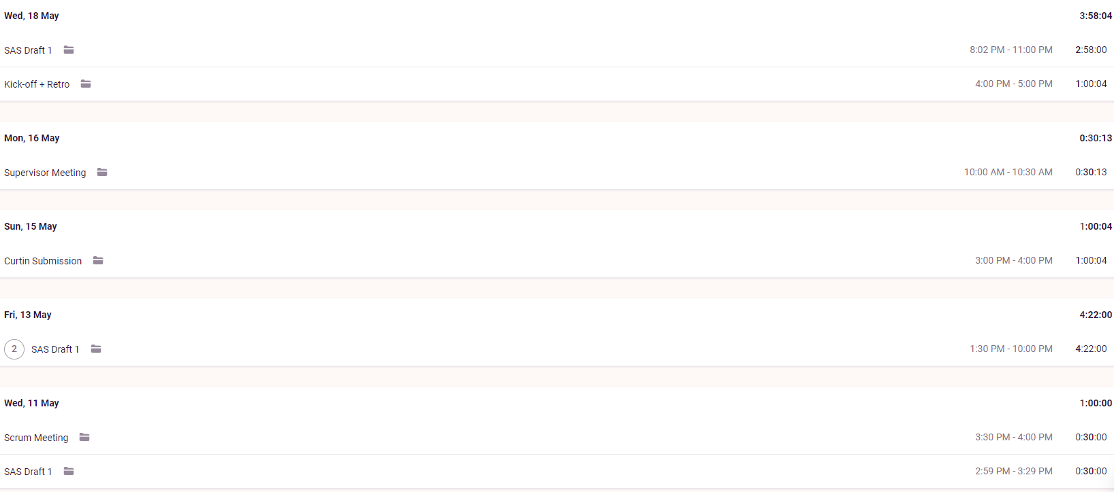

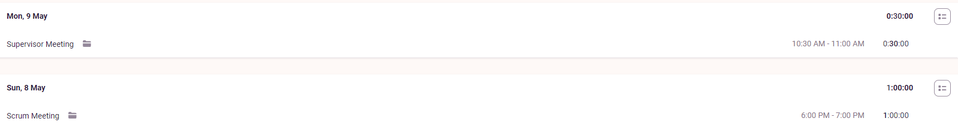

**Supervisor Meetings (9th May, 16th May, 23rd May)**

Took part in supervisor meetings with Amristar. Discussed was the ongoing progress of the SAS.

Minutes taken by Bradley

<https://drive.google.com/drive/folders/1rKsgHWpck5Wpd935lpXTCyADSaPFoQgS?usp=sharing>

**Sprint Kickoff (18th May)**

Sprint kickoffs were run and organised by myself. As our sprints are two weeks long, we discussed what we would be doing the next two weeks, and put these goals into tickets. We then did story point allocation, and assigned these tickets to a person.

Minutes for these meetings were written down by Bradley, who has included these documents in the group report.

<https://drive.google.com/drive/folders/1OImhOwUw_PIgKJ7r6JA-oma24w2zfaJa?usp=sharing>

**Sprint Retrospective (18th May)**

Sprint retrospectives were run and organised by myself. As our sprints are three weeks long, we reflected on how the last 2 weeks had gone, and came up with action items to improve on the next sprint. Retrospective meetings were run by having group members write down what they thought went well, and what could be improved on for the sprint. Every group member was then given 3 votes, and we discussed the highest voted cards.

Minutes for these meetings were written down by Bradley, who has included these documents in the group report.

<https://drive.google.com/drive/folders/1OImhOwUw_PIgKJ7r6JA-oma24w2zfaJa?usp=sharing>

**Scrum Meetings (8th, 11th, 22nd, 24th May)**

Scrum meetings were run and organised by myself. Each meeting consists of the following questions:

* What have you been doing?
* What are you currently doing?
* What will you be doing?
* Are you having problems with anything?

Answers to these questions were written down by Bradley, who has included these documents in this report. We also used the scrum meeting times to discuss submissions, meetings with supervisors and when the next meeting would take place.

<https://drive.google.com/drive/folders/1OImhOwUw_PIgKJ7r6JA-oma24w2zfaJa?usp=sharing>

**SAS Drafts 1 + 2 (3rd May - Current)**

Progress made on the SAD deliverable.

I was responsible for the following sections:

* Business Model - Organisational Context
* Business Model - Current Situation
* Business Model - Solution Definition
* Business Model - Actors
* Business Model - Interactions of Actors
* Business Model - Use Cases

Edit history for the document, including both drafts, can be seen here.

[Software_Architecture_Specification_(v0.1)](https://docs.google.com/document/d/1mcSgu2c_w5R5AETjS3u6trfVxSqU1SJos2QDoY-dQ5o/edit)

[Software_Architecture_Specification_(v1.0)](https://docs.google.com/document/d/1SyL3lQxn-WuiYlmj1VGFqQ0DLbQE_YICIXJrieaQPP4/edit#heading=h.hfkoqxk1unb2)

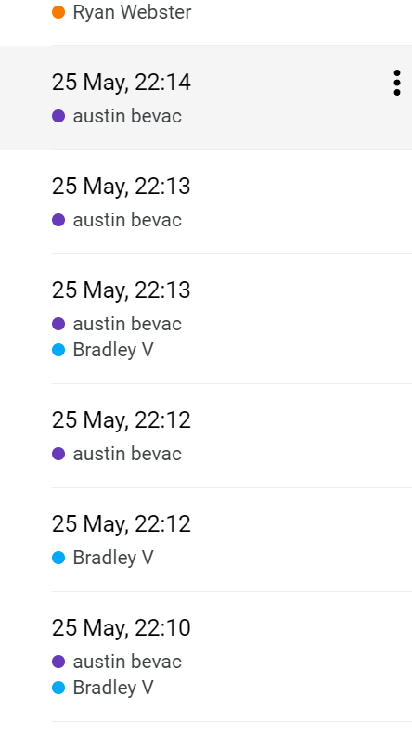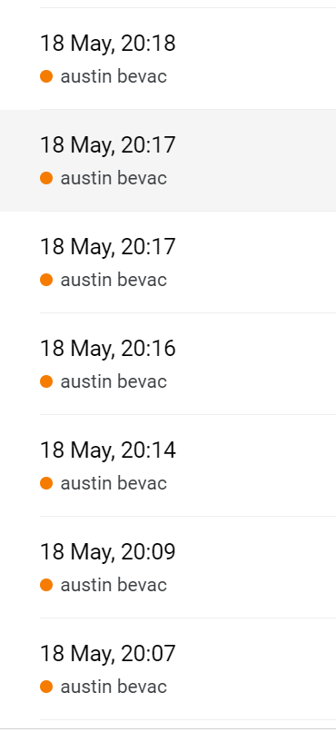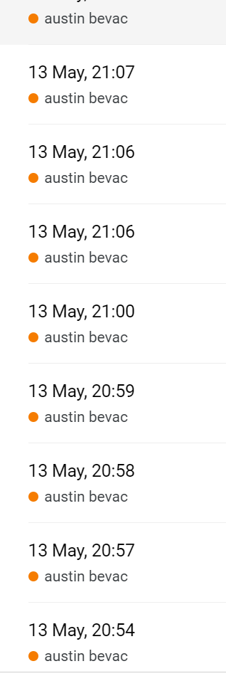

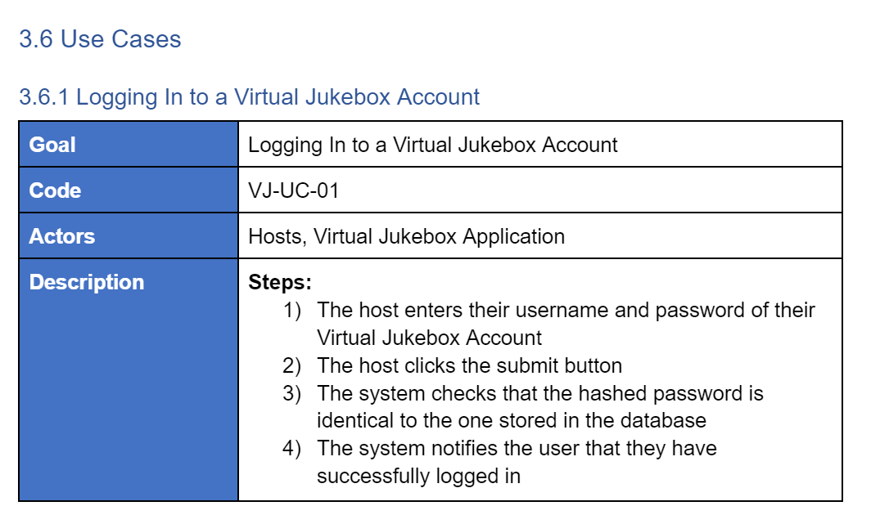

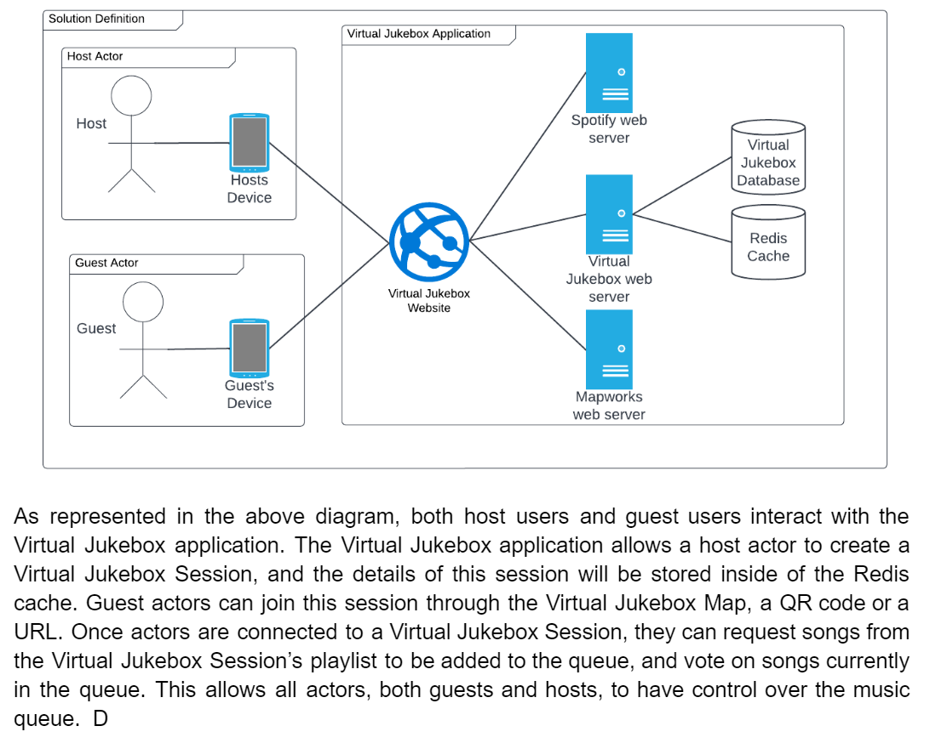

**Curtin Milestone Submission (27th May)**

This document + group report, where I added my work over the previous period.

## Summary

Overall, the group is pleased with the progress we have made with the SAS, and are on track to submit the final submission by this Sunday. Furthermore, the group has started planning for next week’s presentation, and are starting to look ahead at next semester; looking at Docker, design works, and researching branching techniques. It has been difficult to balance this unit along with our other units, as every unit has assessments due before the study week, but we have managed to balance our workload successfully and got back on track.